Prognostic Value of TyHGB Index in Patients with MASLD
An Tran
2026-08-18

1. Baseline characteristics
Table 1: Table 1: Baseline characteristics of the study population according to TyHGB quartiles
Characteristic | Overall N = 710,776,391¹ | Q1 N = 185,307,937¹ | Q2 N = 180,392,729¹ | Q3 N = 177,181,041¹ | Q4 N = 167,894,684¹ | p-value²
Age (years) | 47.86 (15.66) | 44.94 (15.71) | 47.52 (16.00) | 49.82 (15.59) | 49.36 (14.78) | <0.001
Gender |  |  |  |  |  | <0.001
Male | 3,467 (48.7%) | 594 (34.1%) | 860 (49.6%) | 930 (52.4%) | 1,083 (60.1%)
Female | 4,042 (51.3%) | 1,287 (65.9%) | 1,022 (50.4%) | 942 (47.6%) | 791 (39.9%)
Race |  |  |  |  |  | <0.001
Non-Hispanic Black | 1,593 (12.1%) | 570 (17.5%) | 443 (13.7%) | 329 (9.6%) | 251 (7.3%)
Non-Hispanic White | 2,949 (64.4%) | 662 (61.7%) | 692 (61.9%) | 766 (66.5%) | 829 (67.9%)
Other Races | 2,967 (23.5%) | 649 (20.8%) | 747 (24.5%) | 777 (23.9%) | 794 (24.8%)
Education level |  |  |  |  |  | <0.001
Above University | 3,790 (58.4%) | 1,094 (65.2%) | 957 (59.4%) | 877 (53.9%) | 862 (54.6%)
High School - University | 1,729 (23.9%) | 404 (21.1%) | 438 (23.5%) | 470 (27.9%) | 417 (23.3%)
Under High School | 1,990 (17.6%) | 383 (13.6%) | 487 (17.1%) | 525 (18.2%) | 595 (22.0%)
Marital status |  |  |  |  |  | 0.019
Married/Partner | 4,620 (65.0%) | 1,083 (61.7%) | 1,154 (64.7%) | 1,226 (68.6%) | 1,157 (65.2%)
Never married | 1,194 (16.2%) | 365 (18.3%) | 319 (17.5%) | 249 (14.2%) | 261 (14.7%)
Widowed/Divorced/Separated | 1,695 (18.8%) | 433 (20.0%) | 409 (17.8%) | 397 (17.2%) | 456 (20.1%)
Family income to poverty | 2.85 (1.63) | 2.95 (1.65) | 2.91 (1.64) | 2.80 (1.63) | 2.71 (1.59) | <0.001
Body mass index (kg/m²) | 33.29 (6.00) | 30.23 (3.39) | 32.84 (4.81) | 34.46 (6.21) | 35.90 (7.45) | <0.001
Waist circumference (cm) | 109.32 (13.91) | 100.60 (9.17) | 108.14 (11.15) | 112.77 (13.86) | 116.57 (15.49) | <0.001
TyHGB | 10.77 (4.33) | 7.78 (0.53) | 9.15 (0.37) | 10.73 (0.58) | 15.86 (6.33) | <0.001
A Body Shape Index (ABSI) | 0.82 (0.05) | 0.80 (0.05) | 0.82 (0.04) | 0.82 (0.04) | 0.83 (0.04) | <0.001
Weight-Adjusted Waist Index (WWI) | 11.27 (0.75) | 10.99 (0.72) | 11.23 (0.71) | 11.42 (0.70) | 11.49 (0.75) | <0.001
Waist-to-Height Ratio (WHtR) | 0.65 (0.08) | 0.60 (0.06) | 0.64 (0.07) | 0.67 (0.08) | 0.69 (0.10) | <0.001
Total cholesterol (mg/dL) | 194.02 (40.89) | 189.13 (37.27) | 190.85 (38.56) | 194.50 (40.12) | 202.32 (46.33) | <0.001
Triglycerides (mg/dL) | 140.21 (103.10) | 72.43 (24.55) | 104.63 (30.38) | 144.90 (42.53) | 248.31 (152.66) | <0.001
HDL-cholesterol (mg/dL) | 49.47 (13.47) | 61.33 (14.03) | 50.93 (9.83) | 45.54 (8.89) | 38.95 (8.89) | <0.001
Fasting glucose (mmol/L) | 5.86 (1.91) | 5.03 (0.48) | 5.37 (0.59) | 5.75 (0.90) | 7.44 (3.22) | <0.001
ALT (U/L) | 28.78 (20.80) | 25.13 (24.11) | 27.35 (18.68) | 29.76 (18.19) | 33.33 (20.68) | <0.001
AST (U/L) | 25.17 (18.27) | 24.30 (26.69) | 24.04 (12.25) | 25.22 (16.52) | 27.28 (13.09) | <0.001
AST/ALT Ratio | 0.97 (0.28) | 1.05 (0.28) | 0.98 (0.27) | 0.94 (0.27) | 0.91 (0.29) | <0.001
FIB-4 Index | 1.04 (0.79) | 1.03 (1.10) | 0.99 (0.62) | 1.05 (0.67) | 1.07 (0.63) | <0.001
WBC (cells/μL) | 7.09 (2.08) | 6.42 (1.84) | 7.03 (2.06) | 7.27 (2.05) | 7.70 (2.15) | <0.001
Lymphocytes (cells/μL) | 2.10 (0.90) | 1.95 (0.59) | 2.10 (1.05) | 2.14 (1.00) | 2.22 (0.89) | <0.001
Monocytes (cells/μL) | 0.55 (0.20) | 0.51 (0.17) | 0.56 (0.18) | 0.56 (0.23) | 0.58 (0.23) | <0.001
Neutrophils (cells/μL) | 4.18 (1.58) | 3.74 (1.49) | 4.11 (1.52) | 4.30 (1.54) | 4.62 (1.66) | <0.001
RBC (million cells/μL) | 4.79 (0.47) | 4.66 (0.45) | 4.79 (0.46) | 4.84 (0.47) | 4.88 (0.48) | <0.001
Hemoglobin (g/dL) | 14.37 (1.50) | 13.97 (1.45) | 14.36 (1.48) | 14.51 (1.52) | 14.67 (1.48) | <0.001
Hematocrit (%) | 42.37 (4.11) | 41.33 (3.98) | 42.35 (4.06) | 42.79 (4.11) | 43.10 (4.06) | <0.001
Diabetes | 1,156 (14.9%) | 308 (17.2%) | 262 (13.7%) | 265 (12.7%) | 321 (16.0%) | 0.018
Hypertension | 878 (10.5%) | 228 (10.7%) | 220 (10.0%) | 207 (10.7%) | 223 (10.4%) | >0.9
History of cardiovascular disease | 799 (8.5%) | 116 (4.5%) | 155 (6.3%) | 226 (9.7%) | 302 (14.2%) | <0.001
Insulin use | 359 (3.4%) | 24 (0.7%) | 30 (0.9%) | 77 (2.7%) | 228 (10.0%) | <0.001
Oral hypoglycemic agents | 186 (1.6%) | 9 (0.4%) | 23 (0.7%) | 55 (1.6%) | 99 (3.8%) | <0.001
Anti-hypertensive meds | 1,989 (24.1%) | 379 (17.6%) | 472 (23.4%) | 540 (27.0%) | 598 (29.2%) | <0.001
Lipid-lowering meds | 1,444 (17.9%) | 248 (11.8%) | 351 (18.1%) | 392 (20.0%) | 453 (22.2%) | <0.001
All-cause mortality | 526 (5.2%) | 87 (3.2%) | 111 (4.6%) | 140 (5.9%) | 188 (7.4%) | <0.001
Cardiovascular mortality | 171 (1.6%) | 25 (0.7%) | 42 (1.6%) | 46 (1.8%) | 58 (2.3%) | 0.002
¹Mean (SD); n (unweighted) (%)
²Design-based KruskalWallis test; Pearson's X^2: Rao & Scott adjustment

2. Covariate Selection (Multicollinearity Check & DAG)
Table 2
Table 1: Variance Inflation Factor (VIF) for Final Models
 | All-Cause Mortality (ACM) |  |  | Cardiovascular Mortality (CVM)
Covariate | GVIF | Df | GVIF^(1/2Df) | GVIF | Df | GVIF^(1/2Df)
TyHGB | 1.14 | 1 | 1.07 | 1.10 | 1 | 1.05
RIDAGEYR | 1.25 | 1 | 1.12 | 1.31 | 1 | 1.15
RIAGENDR | 1.40 | 1 | 1.18 | 1.52 | 1 | 1.23
RIDRETH1 | 1.36 | 2 | 1.08 | 1.37 | 2 | 1.08
hyperten | 1.08 | 1 | 1.04 | 1.42 | 1 | 1.19
AST_ALT_ratio | 1.49 | 1 | 1.22 | 1.93 | 1 | 1.39
Figure 1: Directed Acyclic Graph (DAG) and Variance Inflation Factor (VIF) confirming covariate selection
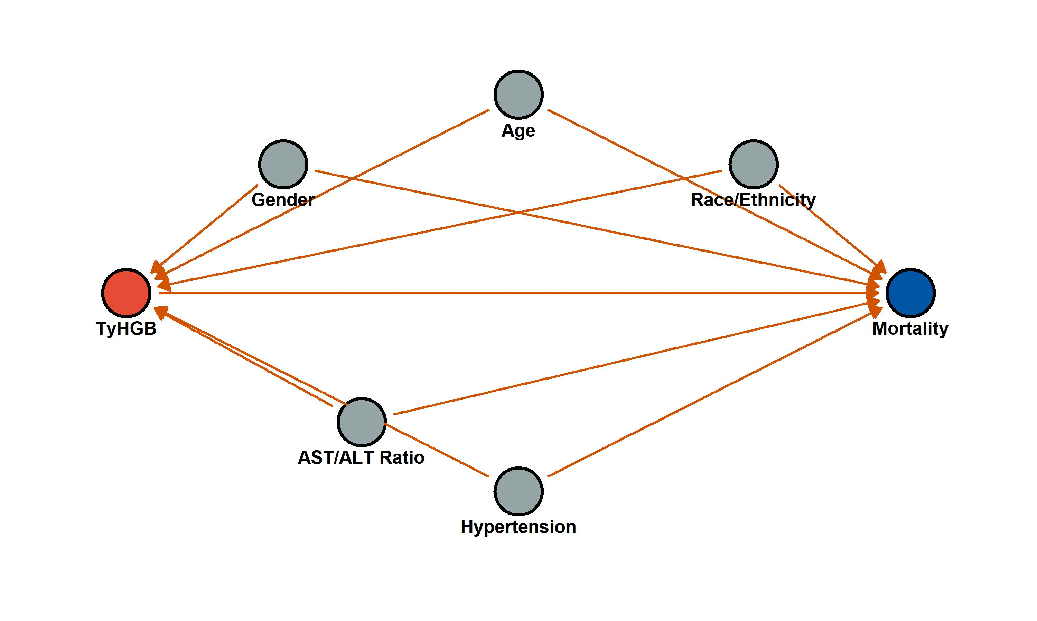
Figure 1: Directed Acyclic Graph (DAG) and Variance Inflation Factor (VIF) confirming covariate selection

3. Independent association of TyHGB with mortality (Stepwise Models)
Stratified 1 - level Cluster Sampling design (with replacement)
With (184) clusters.
svydesign(id = ~SDMVPSU, strata = ~SDMVSTRA, weights = ~WTSAF2YR,
nest = TRUE, data = df_final)
Stratified 1 - level Cluster Sampling design (with replacement)
With (184) clusters.
svydesign(id = ~SDMVPSU, strata = ~SDMVSTRA, weights = ~WTSAF2YR,
nest = TRUE, data = df_final)
Stratified 1 - level Cluster Sampling design (with replacement)
With (184) clusters.
svydesign(id = ~SDMVPSU, strata = ~SDMVSTRA, weights = ~WTSAF2YR,
nest = TRUE, data = df_final)
Stratified 1 - level Cluster Sampling design (with replacement)
With (184) clusters.
svydesign(id = ~SDMVPSU, strata = ~SDMVSTRA, weights = ~WTSAF2YR,
nest = TRUE, data = df_final)
Stratified 1 - level Cluster Sampling design (with replacement)
With (184) clusters.
svydesign(id = ~SDMVPSU, strata = ~SDMVSTRA, weights = ~WTSAF2YR,
nest = TRUE, data = df_final)
Stratified 1 - level Cluster Sampling design (with replacement)
With (184) clusters.
svydesign(id = ~SDMVPSU, strata = ~SDMVSTRA, weights = ~WTSAF2YR,
nest = TRUE, data = df_final)
Stratified 1 - level Cluster Sampling design (with replacement)
With (184) clusters.
svydesign(id = ~SDMVPSU, strata = ~SDMVSTRA, weights = ~WTSAF2YR,
nest = TRUE, data = df_final)
Stratified 1 - level Cluster Sampling design (with replacement)
With (184) clusters.
svydesign(id = ~SDMVPSU, strata = ~SDMVSTRA, weights = ~WTSAF2YR,
nest = TRUE, data = df_final)
Stratified 1 - level Cluster Sampling design (with replacement)
With (184) clusters.
svydesign(id = ~SDMVPSU, strata = ~SDMVSTRA, weights = ~WTSAF2YR,
nest = TRUE, data = df_final)
Stratified 1 - level Cluster Sampling design (with replacement)
With (184) clusters.
svydesign(id = ~SDMVPSU, strata = ~SDMVSTRA, weights = ~WTSAF2YR,
nest = TRUE, data = df_final)
Stratified 1 - level Cluster Sampling design (with replacement)
With (184) clusters.
svydesign(id = ~SDMVPSU, strata = ~SDMVSTRA, weights = ~WTSAF2YR,
nest = TRUE, data = df_final)
Stratified 1 - level Cluster Sampling design (with replacement)
With (184) clusters.
svydesign(id = ~SDMVPSU, strata = ~SDMVSTRA, weights = ~WTSAF2YR,
nest = TRUE, data = df_final)
Stratified 1 - level Cluster Sampling design (with replacement)
With (184) clusters.
svydesign(id = ~SDMVPSU, strata = ~SDMVSTRA, weights = ~WTSAF2YR,
nest = TRUE, data = df_final)
Stratified 1 - level Cluster Sampling design (with replacement)
With (184) clusters.
svydesign(id = ~SDMVPSU, strata = ~SDMVSTRA, weights = ~WTSAF2YR,
nest = TRUE, data = df_final)
Stratified 1 - level Cluster Sampling design (with replacement)
With (184) clusters.
svydesign(id = ~SDMVPSU, strata = ~SDMVSTRA, weights = ~WTSAF2YR,
nest = TRUE, data = df_final)
Stratified 1 - level Cluster Sampling design (with replacement)
With (184) clusters.
svydesign(id = ~SDMVPSU, strata = ~SDMVSTRA, weights = ~WTSAF2YR,
nest = TRUE, data = df_final)
Stratified 1 - level Cluster Sampling design (with replacement)
With (184) clusters.
svydesign(id = ~SDMVPSU, strata = ~SDMVSTRA, weights = ~WTSAF2YR,
nest = TRUE, data = df_final)
Stratified 1 - level Cluster Sampling design (with replacement)
With (184) clusters.
svydesign(id = ~SDMVPSU, strata = ~SDMVSTRA, weights = ~WTSAF2YR,
nest = TRUE, data = df_final)
Stratified 1 - level Cluster Sampling design (with replacement)
With (184) clusters.
svydesign(id = ~SDMVPSU, strata = ~SDMVSTRA, weights = ~WTSAF2YR,
nest = TRUE, data = df_final)
Stratified 1 - level Cluster Sampling design (with replacement)
With (184) clusters.
svydesign(id = ~SDMVPSU, strata = ~SDMVSTRA, weights = ~WTSAF2YR,
nest = TRUE, data = df_final)
Stratified 1 - level Cluster Sampling design (with replacement)
With (184) clusters.
svydesign(id = ~SDMVPSU, strata = ~SDMVSTRA, weights = ~WTSAF2YR,
nest = TRUE, data = df_final)
Stratified 1 - level Cluster Sampling design (with replacement)
With (184) clusters.
svydesign(id = ~SDMVPSU, strata = ~SDMVSTRA, weights = ~WTSAF2YR,
nest = TRUE, data = df_final)
Stratified 1 - level Cluster Sampling design (with replacement)
With (184) clusters.
svydesign(id = ~SDMVPSU, strata = ~SDMVSTRA, weights = ~WTSAF2YR,
nest = TRUE, data = df_final)
Stratified 1 - level Cluster Sampling design (with replacement)
With (184) clusters.
svydesign(id = ~SDMVPSU, strata = ~SDMVSTRA, weights = ~WTSAF2YR,
nest = TRUE, data = df_final)
Table 3: Table 2: Cox regression analysis demonstrating the independent association of TyHGB with mortality
TyHGB | HR (95% CI)_Model 1 (Unadjusted) | P value_Model 1 (Unadjusted) | HR (95% CI)_Model 2 (Demographics) | P value_Model 2 (Demographics) | HR (95% CI)_Model 3 (Fully Adjusted) | P value_Model 3 (Fully Adjusted) | HR (95% CI)_Model 4 (+ Medications) | P value_Model 4 (+ Medications)
All-Cause Mortality
Continuous (per 1-SD) | 1.138 (1.085-1.194) | <0.001 | 1.161 (1.082-1.247) | <0.001 | 1.152 (1.060-1.254) | <0.001 | 1.108 (1.013-1.210) | 0.024
Quartile 1 | Ref. | - | Ref. | - | Ref. | - | Ref. | -
Quartile 2 | 1.353 (0.945-1.938) | 0.099 | 1.048 (0.755-1.453) | 0.781 | 1.072 (0.773-1.487) | 0.677 | 1.095 (0.780-1.537) | 0.601
Quartile 3 | 1.761 (1.304-2.379) | 0.000 | 1.227 (0.904-1.665) | 0.189 | 1.262 (0.946-1.684) | 0.114 | 1.214 (0.886-1.664) | 0.227
Quartile 4 | 2.212 (1.566-3.122) | 0.000 | 1.628 (1.177-2.252) | 0.003 | 1.692 (1.235-2.318) | 0.001 | 1.434 (1.011-2.034) | 0.043
P for trend |  | <0.001 |  | 0.001 |  | <0.001 |  | 0.028
Cardiovascular Mortality
Continuous (per 1-SD) | 1.112 (1.039-1.191) | 0.002 | 1.129 (1.011-1.261) | 0.031 | 1.122 (0.998-1.262) | 0.055 | 1.033 (0.894-1.194) | 0.657
Quartile 1 | Ref. | - | Ref. | - | Ref. | - | Ref. | -
Quartile 2 | 2.030 (1.066-3.866) | 0.031 | 1.536 (0.808-2.920) | 0.191 | 1.584 (0.828-3.029) | 0.165 | 1.591 (0.831-3.045) | 0.161
Quartile 3 | 2.343 (1.330-4.126) | 0.003 | 1.626 (0.899-2.939) | 0.108 | 1.660 (0.921-2.994) | 0.092 | 1.519 (0.830-2.780) | 0.175
Quartile 4 | 2.983 (1.696-5.248) | 0.000 | 2.173 (1.216-3.881) | 0.009 | 2.257 (1.253-4.063) | 0.007 | 1.773 (0.966-3.253) | 0.064
P for trend |  | <0.001 |  | 0.005 |  | 0.004 |  | 0.082

4. Sensitivity Analysis
Stratified 1 - level Cluster Sampling design (with replacement)
With (176) clusters.
subset(masld_design, time_months > 24)
Stratified 1 - level Cluster Sampling design (with replacement)
With (176) clusters.
subset(masld_design, time_months > 24)
Stratified 1 - level Cluster Sampling design (with replacement)
With (176) clusters.
subset(masld_design, time_months > 24)
Stratified 1 - level Cluster Sampling design (with replacement)
With (184) clusters.
subset(masld_design, DIQ050 == "No" & DID070 == "No")
Stratified 1 - level Cluster Sampling design (with replacement)
With (184) clusters.
subset(masld_design, DIQ050 == "No" & DID070 == "No")
Stratified 1 - level Cluster Sampling design (with replacement)
With (184) clusters.
subset(masld_design, DIQ050 == "No" & DID070 == "No")
Stratified 1 - level Cluster Sampling design (with replacement)
With (184) clusters.
subset(masld_design, htn_med == "No")
Stratified 1 - level Cluster Sampling design (with replacement)
With (184) clusters.
subset(masld_design, htn_med == "No")
Stratified 1 - level Cluster Sampling design (with replacement)
With (184) clusters.
subset(masld_design, htn_med == "No")
Stratified 1 - level Cluster Sampling design (with replacement)
With (184) clusters.
subset(masld_design, lipid_med == "No")
Stratified 1 - level Cluster Sampling design (with replacement)
With (184) clusters.
subset(masld_design, lipid_med == "No")
Stratified 1 - level Cluster Sampling design (with replacement)
With (184) clusters.
subset(masld_design, lipid_med == "No")
Stratified 1 - level Cluster Sampling design (with replacement)
With (176) clusters.
subset(masld_design, time_months > 24)
Stratified 1 - level Cluster Sampling design (with replacement)
With (176) clusters.
subset(masld_design, time_months > 24)
Stratified 1 - level Cluster Sampling design (with replacement)
With (176) clusters.
subset(masld_design, time_months > 24)
Stratified 1 - level Cluster Sampling design (with replacement)
With (184) clusters.
subset(masld_design, DIQ050 == "No" & DID070 == "No")
Stratified 1 - level Cluster Sampling design (with replacement)
With (184) clusters.
subset(masld_design, DIQ050 == "No" & DID070 == "No")
Stratified 1 - level Cluster Sampling design (with replacement)
With (184) clusters.
subset(masld_design, DIQ050 == "No" & DID070 == "No")
Stratified 1 - level Cluster Sampling design (with replacement)
With (184) clusters.
subset(masld_design, htn_med == "No")
Stratified 1 - level Cluster Sampling design (with replacement)
With (184) clusters.
subset(masld_design, htn_med == "No")
Stratified 1 - level Cluster Sampling design (with replacement)
With (184) clusters.
subset(masld_design, htn_med == "No")
Stratified 1 - level Cluster Sampling design (with replacement)
With (184) clusters.
subset(masld_design, lipid_med == "No")
Stratified 1 - level Cluster Sampling design (with replacement)
With (184) clusters.
subset(masld_design, lipid_med == "No")
Stratified 1 - level Cluster Sampling design (with replacement)
With (184) clusters.
subset(masld_design, lipid_med == "No")
Table 4: Supplemental Table 1: Sensitivity analyses addressing reverse causation and confounding by medication indications (All analyses performed using Model 3)
TyHGB | HR (95% CI)_Scenario 1: Excluding deaths within 24 months | P value_Scenario 1: Excluding deaths within 24 months | HR (95% CI)_Scenario 2: Excluding patients on Diabetes Medications | P value_Scenario 2: Excluding patients on Diabetes Medications | HR (95% CI)_Scenario 3: Excluding patients on Anti-hypertensive Medications | P value_Scenario 3: Excluding patients on Anti-hypertensive Medications | HR (95% CI)_Scenario 4: Excluding patients on Lipid-lowering Medications | P value_Scenario 4: Excluding patients on Lipid-lowering Medications
All-Cause Mortality
Continuous (per 1-SD) | 1.169 (1.065-1.284) | 0.001 | 1.062 (0.964-1.169) | 0.223 | 1.163 (1.064-1.271) | <0.001 | 1.163 (1.073-1.260) | <0.001
Quartile 1 | Ref. | - | Ref. | - | Ref. | - | Ref. | -
Quartile 2 | 1.131 (0.824-1.553) | 0.446 | 1.094 (0.757-1.580) | 0.632 | 1.066 (0.616-1.846) | 0.818 | 1.034 (0.656-1.629) | 0.885
Quartile 3 | 1.395 (1.040-1.873) | 0.026 | 1.240 (0.905-1.697) | 0.180 | 1.266 (0.796-2.014) | 0.320 | 1.160 (0.778-1.729) | 0.468
Quartile 4 | 1.872 (1.345-2.604) | 0.000 | 1.504 (1.027-2.203) | 0.036 | 1.701 (1.000-2.893) | 0.050 | 1.380 (0.903-2.106) | 0.136
P for trend |  | <0.001 |  | 0.020 |  | 0.030 |  | 0.094
Cardiovascular Mortality
Continuous (per 1-SD) | 1.147 (1.011-1.302) | 0.033 | 1.130 (0.986-1.295) | 0.079 | 1.279 (1.171-1.398) | <0.001 | 1.119 (0.968-1.294) | 0.129
Quartile 1 | Ref. | - | Ref. | - | Ref. | - | Ref. | -
Quartile 2 | 1.415 (0.701-2.856) | 0.332 | 1.855 (0.965-3.567) | 0.064 | 1.589 (0.551-4.584) | 0.392 | 1.180 (0.500-2.784) | 0.705
Quartile 3 | 1.360 (0.728-2.538) | 0.334 | 1.843 (0.993-3.419) | 0.053 | 1.696 (0.647-4.446) | 0.282 | 1.110 (0.527-2.338) | 0.784
Quartile 4 | 2.354 (1.247-4.442) | 0.008 | 2.558 (1.300-5.035) | 0.007 | 4.240 (1.568-11.467) | 0.004 | 1.472 (0.683-3.173) | 0.324
P for trend |  | 0.005 |  | 0.006 |  | 0.002 |  | 0.344

5. Competing Risk Analysis (Fine-Gray Model)
Stratified 1 - level Cluster Sampling design (with replacement)
With (184) clusters.
svydesign(id = ~SDMVPSU, strata = ~SDMVSTRA, weights = ~WTSAF2YR *
fgwt, nest = TRUE, data = fg_data)
Stratified 1 - level Cluster Sampling design (with replacement)
With (184) clusters.
svydesign(id = ~SDMVPSU, strata = ~SDMVSTRA, weights = ~WTSAF2YR *
fgwt, nest = TRUE, data = fg_data)
Stratified 1 - level Cluster Sampling design (with replacement)
With (184) clusters.
svydesign(id = ~SDMVPSU, strata = ~SDMVSTRA, weights = ~WTSAF2YR *
fgwt, nest = TRUE, data = fg_data)
Stratified 1 - level Cluster Sampling design (with replacement)
With (184) clusters.
svydesign(id = ~SDMVPSU, strata = ~SDMVSTRA, weights = ~WTSAF2YR *
fgwt, nest = TRUE, data = fg_data)
Stratified 1 - level Cluster Sampling design (with replacement)
With (184) clusters.
svydesign(id = ~SDMVPSU, strata = ~SDMVSTRA, weights = ~WTSAF2YR *
fgwt, nest = TRUE, data = fg_data)
Stratified 1 - level Cluster Sampling design (with replacement)
With (184) clusters.
svydesign(id = ~SDMVPSU, strata = ~SDMVSTRA, weights = ~WTSAF2YR *
fgwt, nest = TRUE, data = fg_data)
Stratified 1 - level Cluster Sampling design (with replacement)
With (184) clusters.
svydesign(id = ~SDMVPSU, strata = ~SDMVSTRA, weights = ~WTSAF2YR *
fgwt, nest = TRUE, data = fg_data)
Stratified 1 - level Cluster Sampling design (with replacement)
With (184) clusters.
svydesign(id = ~SDMVPSU, strata = ~SDMVSTRA, weights = ~WTSAF2YR *
fgwt, nest = TRUE, data = fg_data)
Stratified 1 - level Cluster Sampling design (with replacement)
With (184) clusters.
svydesign(id = ~SDMVPSU, strata = ~SDMVSTRA, weights = ~WTSAF2YR *
fgwt, nest = TRUE, data = fg_data)
Stratified 1 - level Cluster Sampling design (with replacement)
With (184) clusters.
svydesign(id = ~SDMVPSU, strata = ~SDMVSTRA, weights = ~WTSAF2YR *
fgwt, nest = TRUE, data = fg_data)
Stratified 1 - level Cluster Sampling design (with replacement)
With (184) clusters.
svydesign(id = ~SDMVPSU, strata = ~SDMVSTRA, weights = ~WTSAF2YR *
fgwt, nest = TRUE, data = fg_data)
Stratified 1 - level Cluster Sampling design (with replacement)
With (184) clusters.
svydesign(id = ~SDMVPSU, strata = ~SDMVSTRA, weights = ~WTSAF2YR *
fgwt, nest = TRUE, data = fg_data)
Table 5: Table 3: Competing risk analysis (Fine-Gray model) evaluating the independent association of TyHGB with Cardiovascular Mortality
TyHGB | sHR (95% CI)_Model 1 (Unadjusted) | P value_Model 1 (Unadjusted) | sHR (95% CI)_Model 2 (Demographics) | P value_Model 2 (Demographics) | sHR (95% CI)_Model 3 (Fully Adjusted) | P value_Model 3 (Fully Adjusted) | sHR (95% CI)_Model 4 (+ Medications) | P value_Model 4 (+ Medications)
Cardiovascular Mortality (Fine-Gray)
Continuous (per 1-SD) | 1.111 (1.036-1.192) | 0.003 | 1.125 (1.006-1.259) | 0.039 | 1.127 (1.006-1.263) | 0.039 | 1.042 (0.905-1.200) | 0.567
Quartile 1 | Ref. | - | Ref. | - | Ref. | - | Ref. | -
Quartile 2 | 2.027 (1.064-3.861) | 0.032 | 1.584 (0.824-3.045) | 0.168 | 1.618 (0.841-3.114) | 0.150 | 1.563 (0.811-3.011) | 0.182
Quartile 3 | 2.326 (1.319-4.103) | 0.004 | 1.630 (0.895-2.968) | 0.110 | 1.678 (0.925-3.045) | 0.088 | 1.505 (0.820-2.760) | 0.187
Quartile 4 | 2.938 (1.667-5.178) | 0.000 | 2.158 (1.193-3.905) | 0.011 | 2.271 (1.244-4.144) | 0.008 | 1.779 (0.957-3.310) | 0.069
P for trend |  | <0.001 |  | 0.008 |  | 0.006 |  | 0.082

6. Kaplan-Meier survival analysis
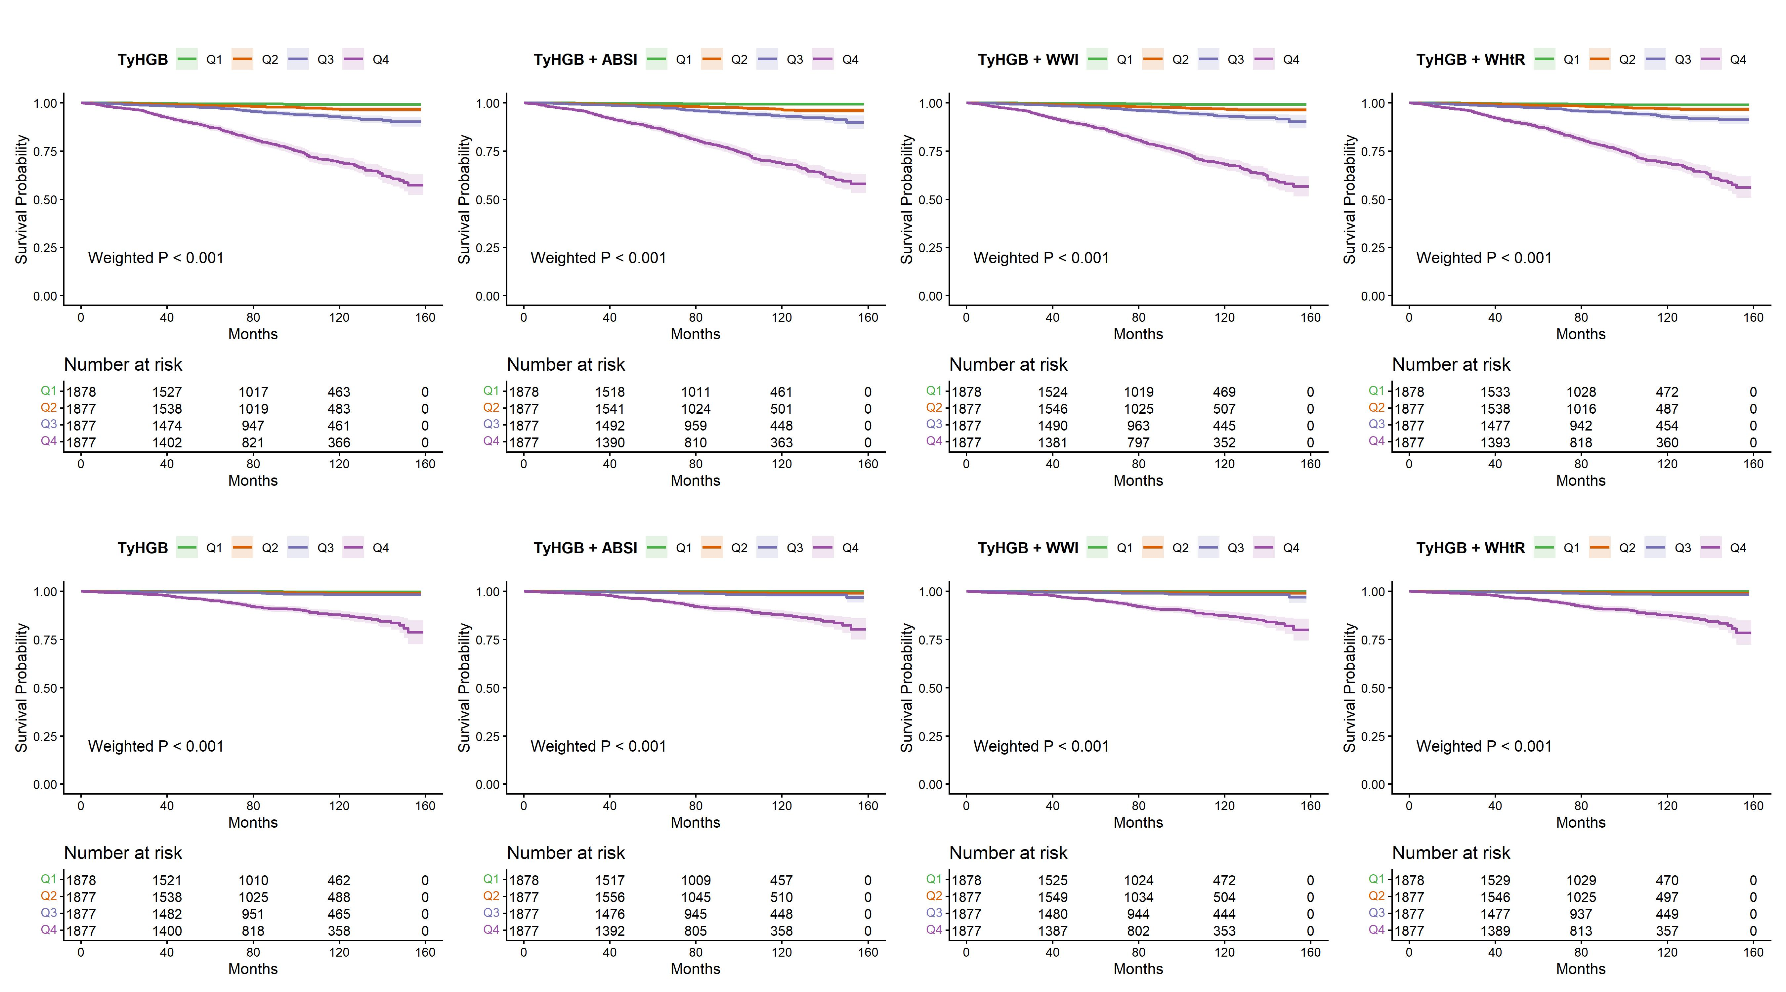
Figure 1: Figure 2: Kaplan-Meier survival curves comparing combining TyHGB with obesity indices

7. Time-dependent ROC Curves
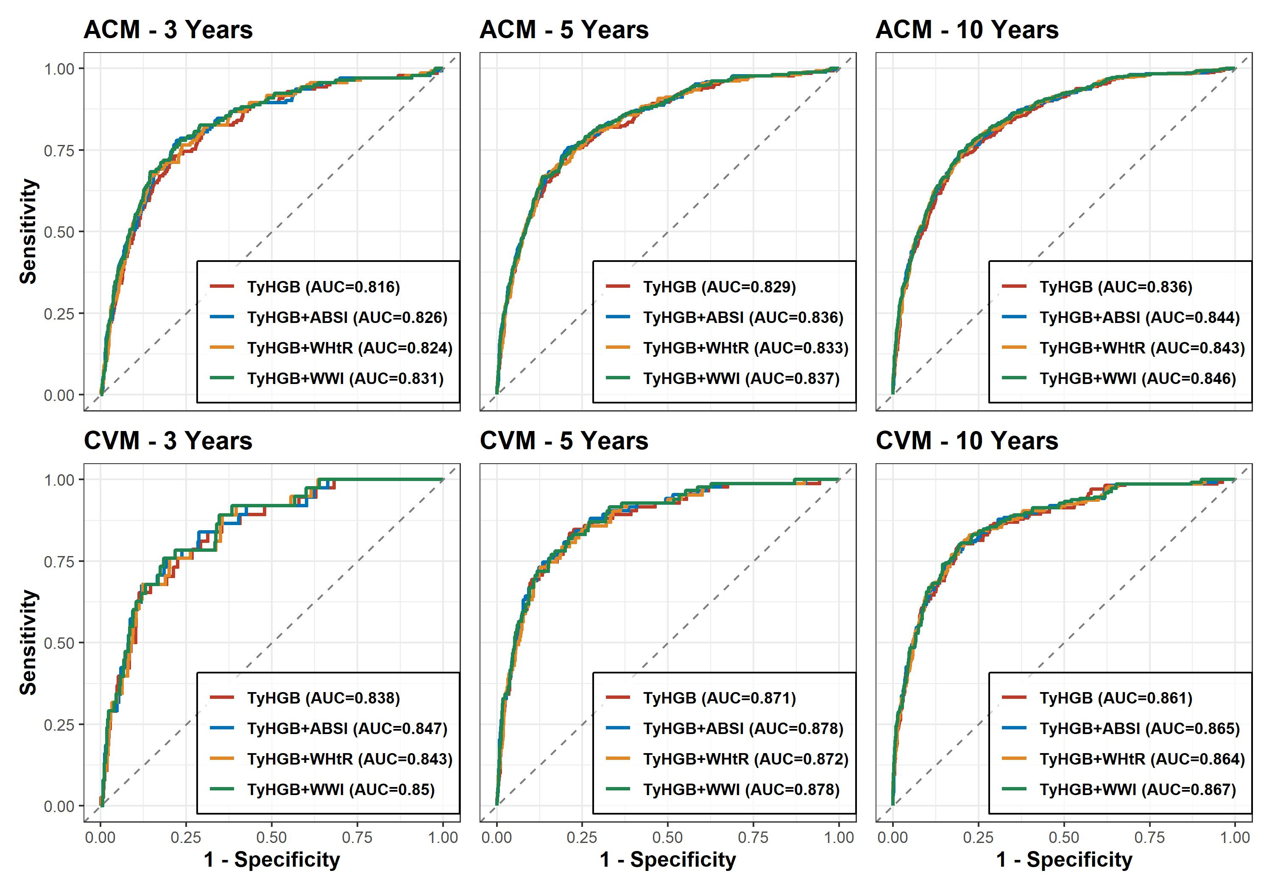
Figure 2: Figure 3: Time-dependent ROC curves comparing combinations of TyHGB and other obesity indices

8. Incremental predictive value (IDI / NRI)
Table 6: Table 4: Incremental predictive value of adding TyHGB and combined indices to the base clinical model
================ KẾT QUẢ CHO: ALL-CAUSE MORTALITY (ACM) TẠI 10 NĂM ================
Base Model (No TyHGB) - C-index: 0.812 (0.781-0.842)
Adding to Base | C-index New (95%CI) | P DeLong | Cont. NRI (95%CI) | P (NRI) | IDI (95%CI) | P (IDI)
------------------------------------------------------------------------------------------------------------
Est. Lower Upper p-value
M1 0.002 -0.002 0.005 0.396
M2 0.178 0.059 0.272 0.000
M3 -0.001 -0.002 0.002 0.475
+ TyHGB | 0.815 (0.783-0.846) | 0.9021 | -0.001 (-0.002-0.002) | 0.4750 | 0.002 (-0.002-0.005) | 0.3960
Est. Lower Upper p-value
M1 0.017 0.009 0.028 0
M2 0.206 0.112 0.309 0
M3 0.009 0.004 0.016 0
+ TyHGB + ABSI | 0.820 (0.790-0.851) | 0.6944 | 0.009 (0.004-0.016) | <0.001 | 0.017 (0.009-0.028) | <0.001
Est. Lower Upper p-value
M1 0.020 0.010 0.030 0
M2 0.185 0.080 0.271 0
M3 0.010 0.003 0.018 0
+ TyHGB + WWI | 0.823 (0.791-0.854) | 0.6280 | 0.010 (0.003-0.018) | <0.001 | 0.020 (0.010-0.030) | <0.001
Est. Lower Upper p-value
M1 0.011 0.003 0.017 0.000
M2 0.186 0.074 0.249 0.000
M3 0.003 -0.001 0.008 0.059
+ TyHGB + WHtR | 0.819 (0.788-0.850) | 0.7502 | 0.003 (-0.001-0.008) | 0.0590 | 0.011 (0.003-0.017) | <0.001
================ KẾT QUẢ CHO: CARDIOVASCULAR MORTALITY (CVM) TẠI 10 NĂM ================
Base Model (No TyHGB) - C-index: 0.868 (0.837-0.898)
Adding to Base | C-index New (95%CI) | P DeLong | Cont. NRI (95%CI) | P (NRI) | IDI (95%CI) | P (IDI)
------------------------------------------------------------------------------------------------------------
Est. Lower Upper p-value
M1 0.000 -0.002 0.003 0.911
M2 0.169 0.011 0.295 0.020
M3 -0.001 -0.001 0.001 0.238
+ TyHGB | 0.870 (0.840-0.899) | 0.9204 | -0.001 (-0.001-0.001) | 0.2380 | 0.000 (-0.002-0.003) | 0.9110
Est. Lower Upper p-value
M1 0.006 0.000 0.015 0.079
M2 0.169 0.028 0.320 0.020
M3 0.001 0.000 0.005 0.020
+ TyHGB + ABSI | 0.875 (0.846-0.904) | 0.7333 | 0.001 (0.000-0.005) | 0.0200 | 0.006 (-0.000-0.015) | 0.0790
Est. Lower Upper p-value
M1 0.009 0.000 0.020 0.04
M2 0.188 0.013 0.316 0.02
M3 0.002 0.000 0.010 0.04
+ TyHGB + WWI | 0.877 (0.849-0.905) | 0.6607 | 0.002 (0.000-0.010) | 0.0400 | 0.009 (0.000-0.020) | 0.0400
Est. Lower Upper p-value
M1 0.003 -0.002 0.011 0.257
M2 0.135 -0.031 0.254 0.119
M3 0.000 -0.003 0.003 0.772
+ TyHGB + WHtR | 0.873 (0.845-0.901) | 0.8084 | 0.000 (-0.003-0.003) | 0.7720 | 0.003 (-0.002-0.011) | 0.2570

9. Dose-response relationship (RCS)
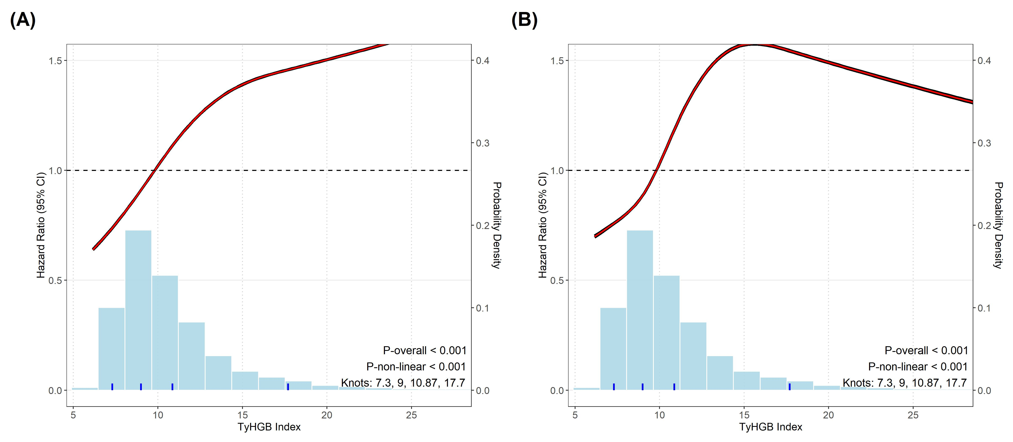
Figure 3: Figure 4: Restricted cubic spline (RCS) curves showing the dose-response relationship between TyHGB index and mortality

10. Threshold Effect Analysis (Two-piecewise Cox Model)
Stratified 1 - level Cluster Sampling design (with replacement)
With (184) clusters.
svydesign(id = ~SDMVPSU, strata = ~SDMVSTRA, weights = ~WTSAF2YR,
nest = TRUE, data = d_opt)
Stratified 1 - level Cluster Sampling design (with replacement)
With (184) clusters.
svydesign(id = ~SDMVPSU, strata = ~SDMVSTRA, weights = ~WTSAF2YR,
nest = TRUE, data = d_opt)
Stratified 1 - level Cluster Sampling design (with replacement)
With (184) clusters.
svydesign(id = ~SDMVPSU, strata = ~SDMVSTRA, weights = ~WTSAF2YR,
nest = TRUE, data = d_opt)
Stratified 1 - level Cluster Sampling design (with replacement)
With (184) clusters.
svydesign(id = ~SDMVPSU, strata = ~SDMVSTRA, weights = ~WTSAF2YR,
nest = TRUE, data = d_opt)
Stratified 1 - level Cluster Sampling design (with replacement)
With (184) clusters.
svydesign(id = ~SDMVPSU, strata = ~SDMVSTRA, weights = ~WTSAF2YR,
nest = TRUE, data = d_opt)
Stratified 1 - level Cluster Sampling design (with replacement)
With (184) clusters.
svydesign(id = ~SDMVPSU, strata = ~SDMVSTRA, weights = ~WTSAF2YR,
nest = TRUE, data = d_opt)
Table 7: Table 5: Threshold effect analysis and Dichotomized HR of TyHGB on ACM and CVM
Model | HR (95% CI) | P value
All-Cause Mortality
Standard linear model | 1.030 (1.012-1.048) | <0.001
Two-piecewise model (Slope evaluation)
TyHGB < 12.1 (Events: 363) | 1.119 (1.050-1.192) | <0.001
TyHGB >= 12.1 (Events: 163) | 1.016 (0.994-1.039) | 0.157
P for LRT |  | 0.012
Dichotomized by Threshold (Clinical HR)
Low Risk (< 12.1) | Ref. | -
High Risk (>= 12.1) | 1.376 (1.087-1.742) | 0.008
Cardiovascular Mortality
Standard linear model | 1.024 (1.000-1.049) | 0.055
Two-piecewise model (Slope evaluation)
TyHGB < 11.9 (Events: 116) | 1.190 (1.047-1.352) | 0.008
TyHGB >= 11.9 (Events: 55) | 0.992 (0.945-1.042) | 0.762
P for LRT |  | 0.018
Dichotomized by Threshold (Clinical HR)
Low Risk (< 11.9) | Ref. | -
High Risk (>= 11.9) | 1.487 (1.056-2.095) | 0.023

11. Subgroup analyses
Stratified 1 - level Cluster Sampling design (with replacement)
With (184) clusters.
subset(sub_design, get(col_name) == lvl)
Stratified 1 - level Cluster Sampling design (with replacement)
With (184) clusters.
subset(sub_design, get(col_name) == lvl)
Stratified 1 - level Cluster Sampling design (with replacement)
With (184) clusters.
subset(sub_design, get(col_name) == lvl)
Stratified 1 - level Cluster Sampling design (with replacement)
With (184) clusters.
subset(sub_design, get(col_name) == lvl)
Stratified 1 - level Cluster Sampling design (with replacement)
With (184) clusters.
subset(sub_design, get(col_name) == lvl)
Stratified 1 - level Cluster Sampling design (with replacement)
With (184) clusters.
subset(sub_design, get(col_name) == lvl)
Stratified 1 - level Cluster Sampling design (with replacement)
With (182) clusters.
subset(sub_design, get(col_name) == lvl)
Stratified 1 - level Cluster Sampling design (with replacement)
With (184) clusters.
subset(sub_design, get(col_name) == lvl)
Stratified 1 - level Cluster Sampling design (with replacement)
With (184) clusters.
subset(sub_design, get(col_name) == lvl)
Stratified 1 - level Cluster Sampling design (with replacement)
With (116) clusters.
subset(sub_design, get(col_name) == lvl)
Stratified 1 - level Cluster Sampling design (with replacement)
With (184) clusters.
subset(sub_design, get(col_name) == lvl)
Stratified 1 - level Cluster Sampling design (with replacement)
With (184) clusters.
subset(sub_design, get(col_name) == lvl)
Stratified 1 - level Cluster Sampling design (with replacement)
With (184) clusters.
subset(sub_design, get(col_name) == lvl)
Stratified 1 - level Cluster Sampling design (with replacement)
With (184) clusters.
subset(sub_design, get(col_name) == lvl)
Stratified 1 - level Cluster Sampling design (with replacement)
With (184) clusters.
subset(sub_design, get(col_name) == lvl)
Stratified 1 - level Cluster Sampling design (with replacement)
With (184) clusters.
subset(sub_design, get(col_name) == lvl)
Stratified 1 - level Cluster Sampling design (with replacement)
With (182) clusters.
subset(sub_design, get(col_name) == lvl)
Stratified 1 - level Cluster Sampling design (with replacement)
With (184) clusters.
subset(sub_design, get(col_name) == lvl)
Stratified 1 - level Cluster Sampling design (with replacement)
With (184) clusters.
subset(sub_design, get(col_name) == lvl)
Stratified 1 - level Cluster Sampling design (with replacement)
With (116) clusters.
subset(sub_design, get(col_name) == lvl)
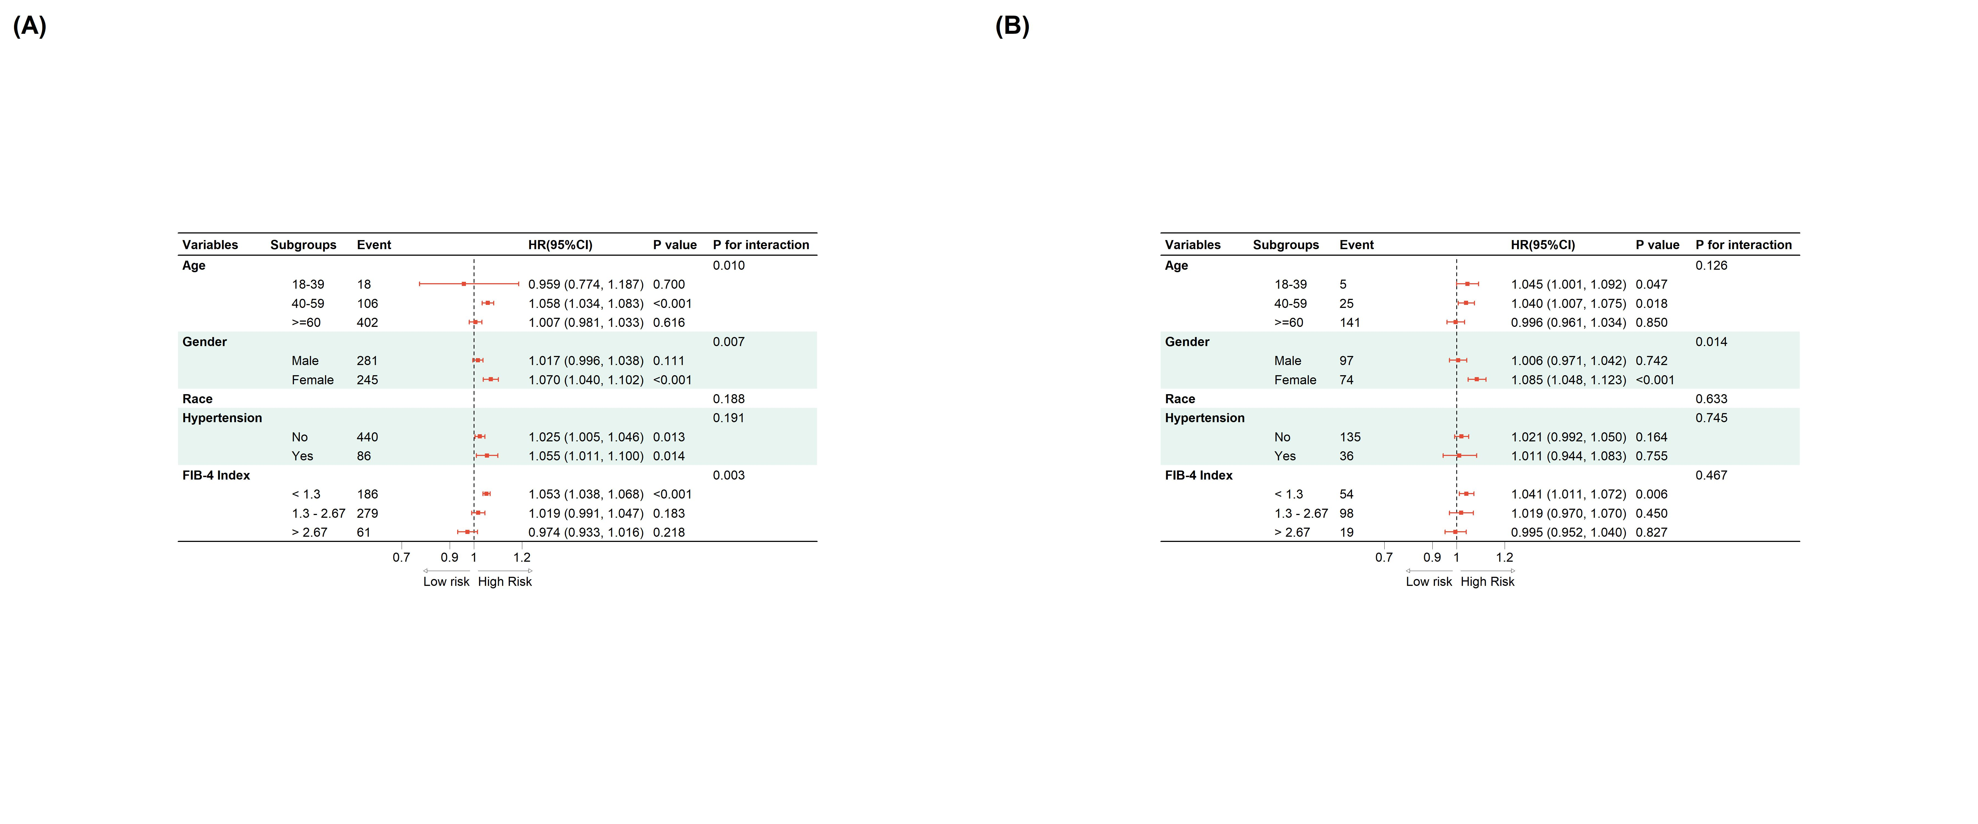
Figure 4: Figure 5: Subgroup analyses for the association between TyHGB index and mortality risk

12. Detailed Mediation Analysis
Stratified 1 - level Cluster Sampling design (with replacement)
With (184) clusters.
svydesign(id = ~SDMVPSU, strata = ~SDMVSTRA, weights = ~WTSAF2YR,
nest = TRUE, data = d_clean)
Stratified 1 - level Cluster Sampling design (with replacement)
With (184) clusters.
svydesign(id = ~SDMVPSU, strata = ~SDMVSTRA, weights = ~WTSAF2YR,
nest = TRUE, data = d_clean)
Stratified 1 - level Cluster Sampling design (with replacement)
With (184) clusters.
svydesign(id = ~SDMVPSU, strata = ~SDMVSTRA, weights = ~WTSAF2YR,
nest = TRUE, data = d_clean)
Stratified 1 - level Cluster Sampling design (with replacement)
With (184) clusters.
svydesign(id = ~SDMVPSU, strata = ~SDMVSTRA, weights = ~WTSAF2YR,
nest = TRUE, data = d_clean)
Stratified 1 - level Cluster Sampling design (with replacement)
With (184) clusters.
svydesign(id = ~SDMVPSU, strata = ~SDMVSTRA, weights = ~WTSAF2YR,
nest = TRUE, data = d_clean)
Stratified 1 - level Cluster Sampling design (with replacement)
With (184) clusters.
svydesign(id = ~SDMVPSU, strata = ~SDMVSTRA, weights = ~WTSAF2YR,
nest = TRUE, data = d_clean)
Stratified 1 - level Cluster Sampling design (with replacement)
With (184) clusters.
svydesign(id = ~SDMVPSU, strata = ~SDMVSTRA, weights = ~WTSAF2YR,
nest = TRUE, data = d_clean)
Stratified 1 - level Cluster Sampling design (with replacement)
With (184) clusters.
svydesign(id = ~SDMVPSU, strata = ~SDMVSTRA, weights = ~WTSAF2YR,
nest = TRUE, data = d_clean)
Stratified 1 - level Cluster Sampling design (with replacement)
With (184) clusters.
svydesign(id = ~SDMVPSU, strata = ~SDMVSTRA, weights = ~WTSAF2YR,
nest = TRUE, data = d_clean)
Stratified 1 - level Cluster Sampling design (with replacement)
With (184) clusters.
svydesign(id = ~SDMVPSU, strata = ~SDMVSTRA, weights = ~WTSAF2YR,
nest = TRUE, data = d_clean)
Stratified 1 - level Cluster Sampling design (with replacement)
With (184) clusters.
svydesign(id = ~SDMVPSU, strata = ~SDMVSTRA, weights = ~WTSAF2YR,
nest = TRUE, data = d_clean)
Stratified 1 - level Cluster Sampling design (with replacement)
With (184) clusters.
svydesign(id = ~SDMVPSU, strata = ~SDMVSTRA, weights = ~WTSAF2YR,
nest = TRUE, data = d_clean)
Stratified 1 - level Cluster Sampling design (with replacement)
With (184) clusters.
svydesign(id = ~SDMVPSU, strata = ~SDMVSTRA, weights = ~WTSAF2YR,
nest = TRUE, data = d_clean)
Stratified 1 - level Cluster Sampling design (with replacement)
With (184) clusters.
svydesign(id = ~SDMVPSU, strata = ~SDMVSTRA, weights = ~WTSAF2YR,
nest = TRUE, data = d_clean)
Stratified 1 - level Cluster Sampling design (with replacement)
With (184) clusters.
svydesign(id = ~SDMVPSU, strata = ~SDMVSTRA, weights = ~WTSAF2YR,
nest = TRUE, data = d_clean)
Stratified 1 - level Cluster Sampling design (with replacement)
With (184) clusters.
svydesign(id = ~SDMVPSU, strata = ~SDMVSTRA, weights = ~WTSAF2YR,
nest = TRUE, data = d_clean)
Stratified 1 - level Cluster Sampling design (with replacement)
With (184) clusters.
svydesign(id = ~SDMVPSU, strata = ~SDMVSTRA, weights = ~WTSAF2YR,
nest = TRUE, data = d_clean)
Stratified 1 - level Cluster Sampling design (with replacement)
With (184) clusters.
svydesign(id = ~SDMVPSU, strata = ~SDMVSTRA, weights = ~WTSAF2YR,
nest = TRUE, data = d_clean)
Stratified 1 - level Cluster Sampling design (with replacement)
With (184) clusters.
svydesign(id = ~SDMVPSU, strata = ~SDMVSTRA, weights = ~WTSAF2YR,
nest = TRUE, data = d_clean)
Stratified 1 - level Cluster Sampling design (with replacement)
With (184) clusters.
svydesign(id = ~SDMVPSU, strata = ~SDMVSTRA, weights = ~WTSAF2YR,
nest = TRUE, data = d_clean)
Stratified 1 - level Cluster Sampling design (with replacement)
With (184) clusters.
svydesign(id = ~SDMVPSU, strata = ~SDMVSTRA, weights = ~WTSAF2YR,
nest = TRUE, data = d_clean)
Stratified 1 - level Cluster Sampling design (with replacement)
With (184) clusters.
svydesign(id = ~SDMVPSU, strata = ~SDMVSTRA, weights = ~WTSAF2YR,
nest = TRUE, data = d_clean)
Stratified 1 - level Cluster Sampling design (with replacement)
With (184) clusters.
svydesign(id = ~SDMVPSU, strata = ~SDMVSTRA, weights = ~WTSAF2YR,
nest = TRUE, data = d_clean)
Stratified 1 - level Cluster Sampling design (with replacement)
With (184) clusters.
svydesign(id = ~SDMVPSU, strata = ~SDMVSTRA, weights = ~WTSAF2YR,
nest = TRUE, data = d_clean)
Stratified 1 - level Cluster Sampling design (with replacement)
With (184) clusters.
svydesign(id = ~SDMVPSU, strata = ~SDMVSTRA, weights = ~WTSAF2YR,
nest = TRUE, data = d_clean)
Stratified 1 - level Cluster Sampling design (with replacement)
With (184) clusters.
svydesign(id = ~SDMVPSU, strata = ~SDMVSTRA, weights = ~WTSAF2YR,
nest = TRUE, data = d_clean)
Stratified 1 - level Cluster Sampling design (with replacement)
With (184) clusters.
svydesign(id = ~SDMVPSU, strata = ~SDMVSTRA, weights = ~WTSAF2YR,
nest = TRUE, data = d_clean)
Stratified 1 - level Cluster Sampling design (with replacement)
With (184) clusters.
svydesign(id = ~SDMVPSU, strata = ~SDMVSTRA, weights = ~WTSAF2YR,
nest = TRUE, data = d_clean)
Stratified 1 - level Cluster Sampling design (with replacement)
With (184) clusters.
svydesign(id = ~SDMVPSU, strata = ~SDMVSTRA, weights = ~WTSAF2YR,
nest = TRUE, data = d_clean)
Stratified 1 - level Cluster Sampling design (with replacement)
With (184) clusters.
svydesign(id = ~SDMVPSU, strata = ~SDMVSTRA, weights = ~WTSAF2YR,
nest = TRUE, data = d_clean)
Stratified 1 - level Cluster Sampling design (with replacement)
With (184) clusters.
svydesign(id = ~SDMVPSU, strata = ~SDMVSTRA, weights = ~WTSAF2YR,
nest = TRUE, data = d_clean)
Stratified 1 - level Cluster Sampling design (with replacement)
With (184) clusters.
svydesign(id = ~SDMVPSU, strata = ~SDMVSTRA, weights = ~WTSAF2YR,
nest = TRUE, data = d_clean)
Stratified 1 - level Cluster Sampling design (with replacement)
With (184) clusters.
svydesign(id = ~SDMVPSU, strata = ~SDMVSTRA, weights = ~WTSAF2YR,
nest = TRUE, data = d_clean)
Stratified 1 - level Cluster Sampling design (with replacement)
With (184) clusters.
svydesign(id = ~SDMVPSU, strata = ~SDMVSTRA, weights = ~WTSAF2YR,
nest = TRUE, data = d_clean)
Stratified 1 - level Cluster Sampling design (with replacement)
With (184) clusters.
svydesign(id = ~SDMVPSU, strata = ~SDMVSTRA, weights = ~WTSAF2YR,
nest = TRUE, data = d_clean)
Stratified 1 - level Cluster Sampling design (with replacement)
With (184) clusters.
svydesign(id = ~SDMVPSU, strata = ~SDMVSTRA, weights = ~WTSAF2YR,
nest = TRUE, data = d_clean)
Table 8: Supplemental Table 5: Detailed mediation analysis of TyHGB on ACM and CVM via multiple biomarkers
Mediator | ACME (95% CI) | P (ACME) | ADE (95% CI) | P (ADE) | Prop. Mediated (%)
All-cause mortality
Uric Acid | 0.002 (-0.001 to 0.005) | 0.118 | 0.027 (0.009 to 0.046) | 0.004 | 7.21%
WBC Count | 0.004 (0.001 to 0.007) | 0.003 | 0.027 (0.010 to 0.045) | 0.002 | 13.68%
Neutrophils | 0.011 (0.007 to 0.015) | <0.001 | 0.027 (0.010 to 0.044) | 0.002 | 38.07%
HbA1c | 0.023 (0.013 to 0.033) | <0.001 | 0.011 (-0.007 to 0.028) | 0.220 | 78.05%
RDW | 0.001 (-0.000 to 0.002) | 0.199 | 0.029 (0.011 to 0.047) | 0.002 | 2.82%
ALP | 0.006 (0.003 to 0.008) | <0.001 | 0.026 (0.007 to 0.044) | 0.006 | 19.08%
Cardiovascular mortality
Uric Acid | 0.005 (-0.001 to 0.010) | 0.097 | 0.018 (-0.011 to 0.048) | 0.224 | 19.95%
WBC Count | 0.004 (0.001 to 0.007) | 0.023 | 0.021 (-0.004 to 0.046) | 0.098 | 15.81%
Neutrophils | 0.014 (0.009 to 0.019) | <0.001 | 0.020 (-0.008 to 0.047) | 0.166 | 56.39%
HbA1c | 0.029 (0.010 to 0.049) | 0.003 | -0.006 (-0.043 to 0.031) | 0.747 | 124.07%
RDW | 0.001 (-0.000 to 0.002) | 0.203 | 0.023 (-0.002 to 0.048) | 0.072 | 3.47%
ALP | 0.008 (0.004 to 0.012) | <0.001 | 0.018 (-0.007 to 0.043) | 0.157 | 35.29%


Figure 5: Supplemental Figure 2: Mediation analysis path diagrams of the TyHGB index on mortality via multiple biomarkers

13. Construction of Nomograms
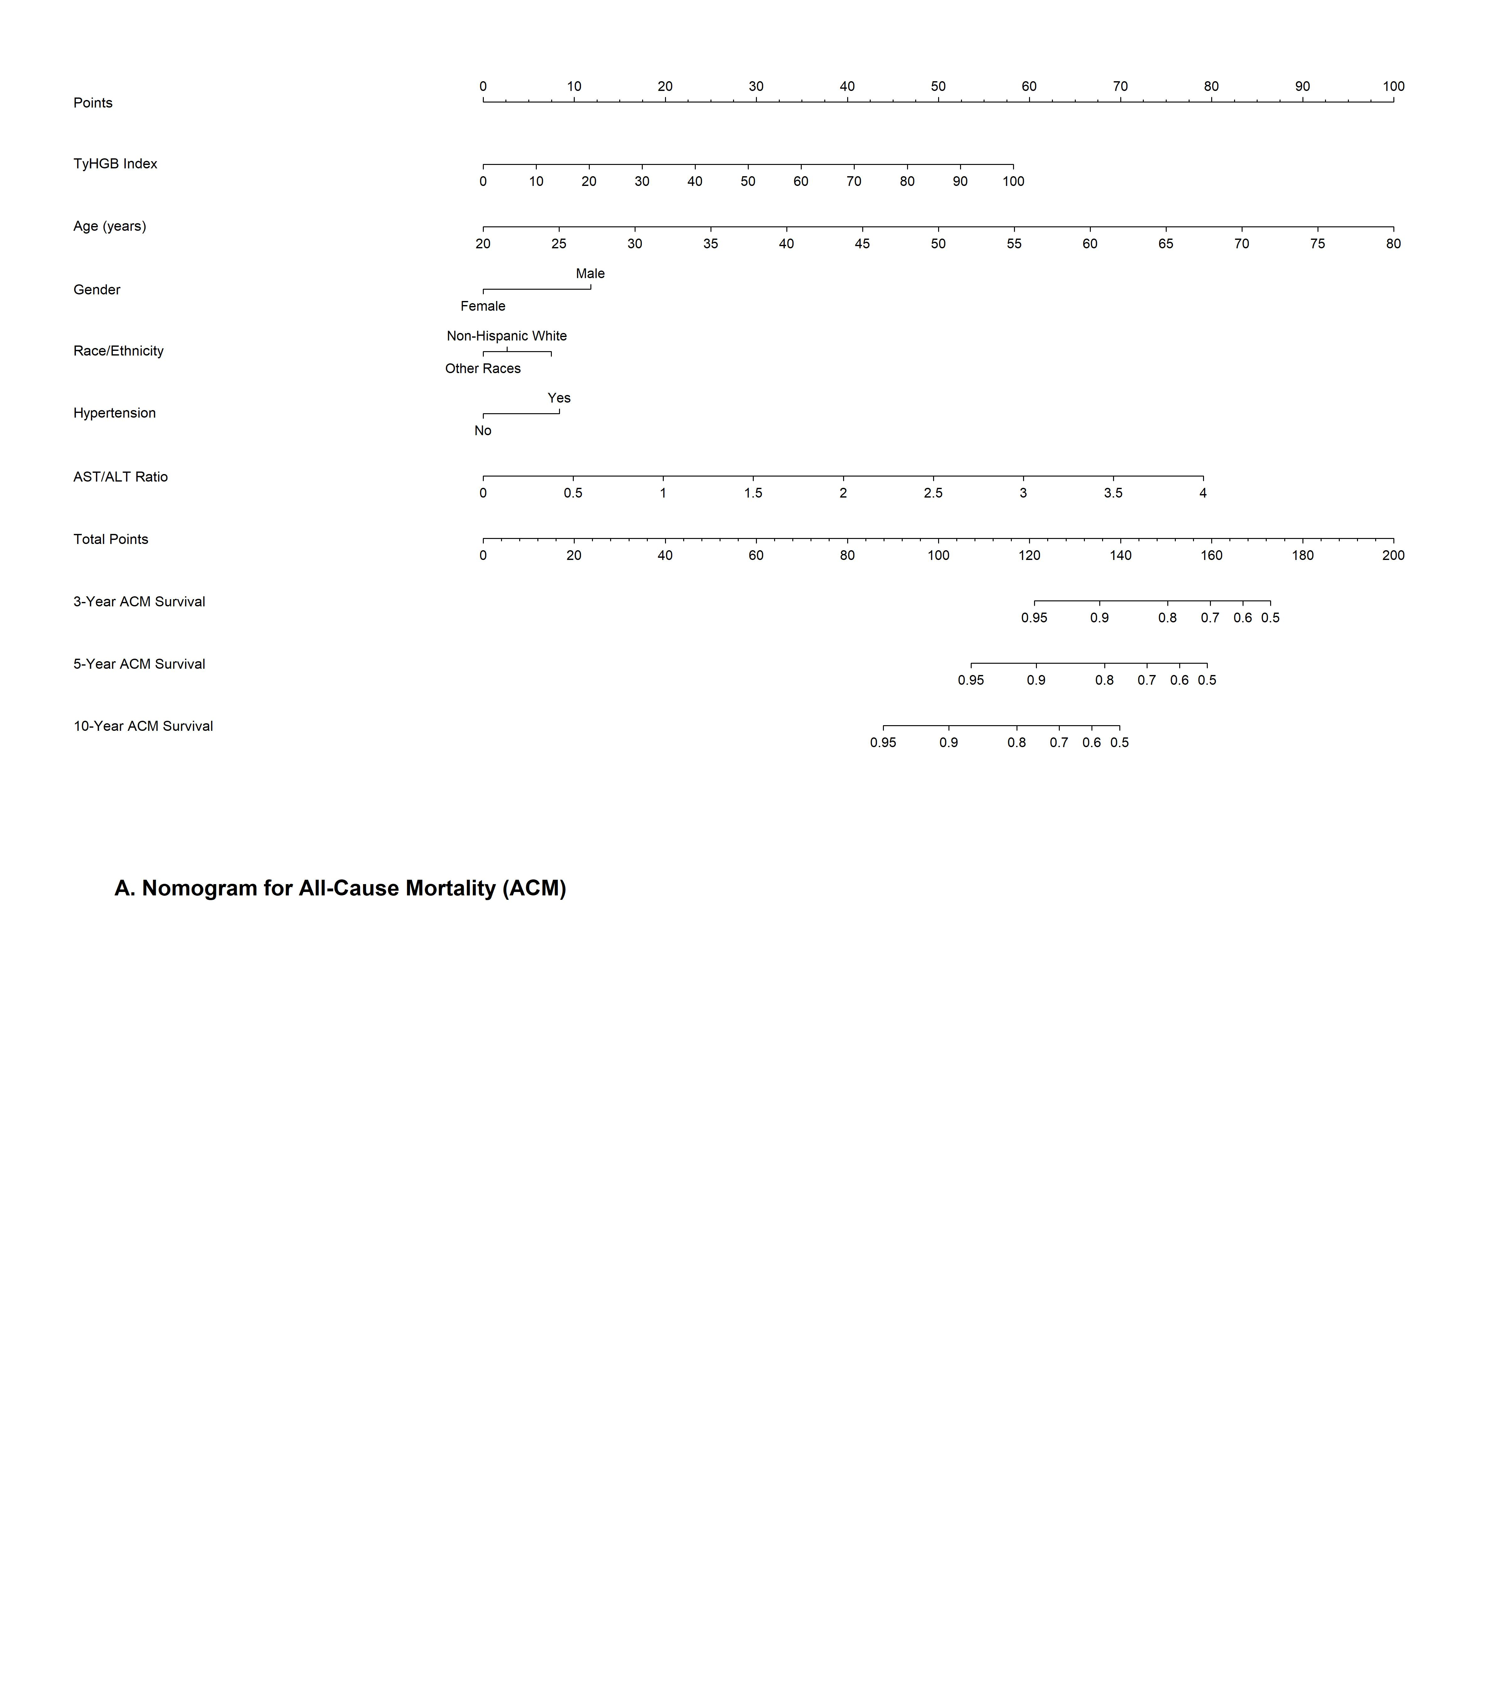
Figure 6: Figure 6: Nomograms predicting 3-, 5-, and 10-year survival probabilities for ACM (A) and CVM (B)
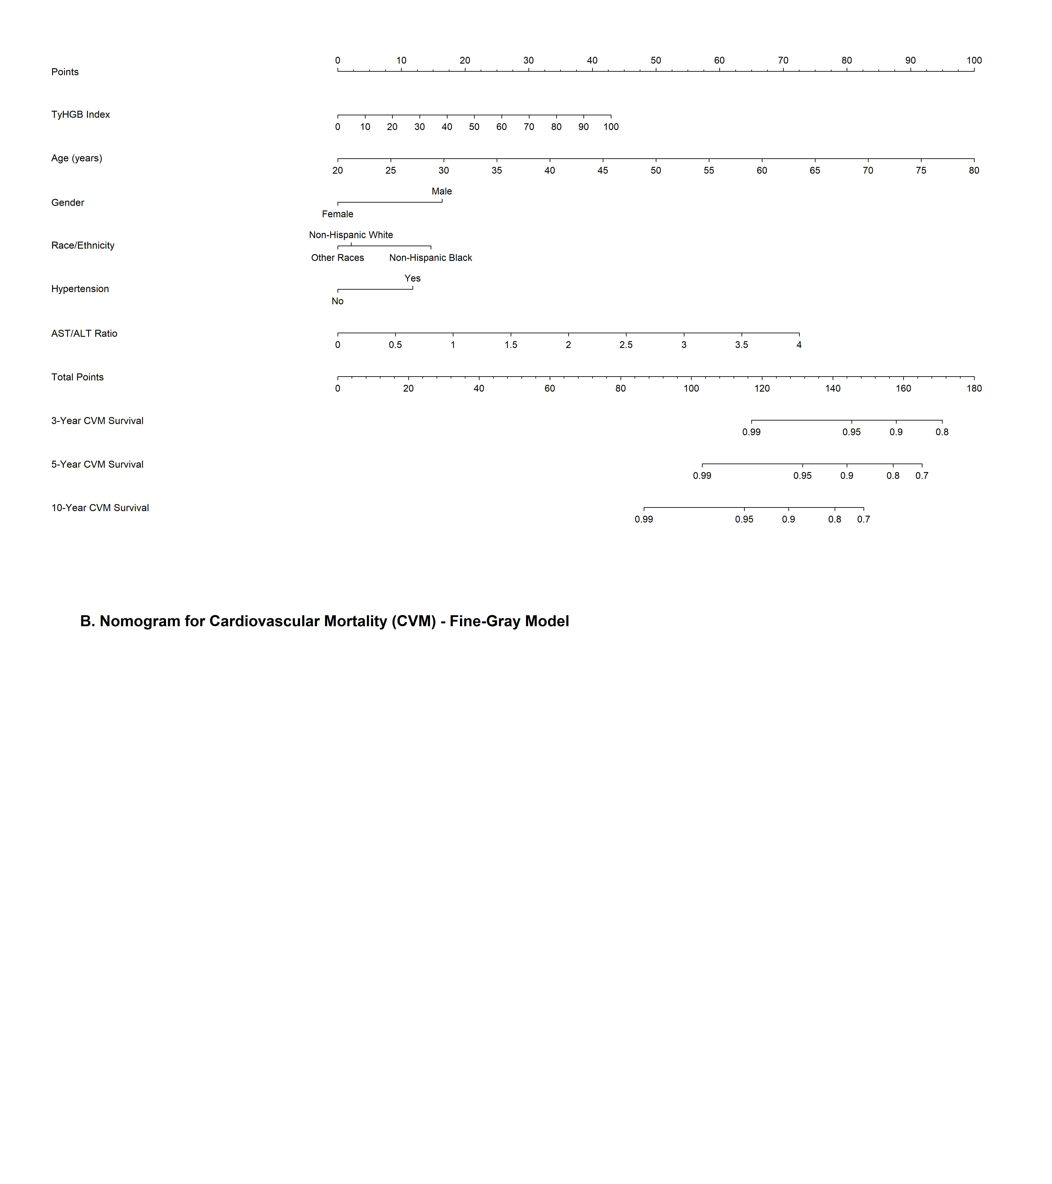
Figure 7: Figure 6: Nomograms predicting 3-, 5-, and 10-year survival probabilities for ACM (A) and CVM (B)

14. Calibration Plots
Using Cox survival estimates at 120 Days
Using Cox survival estimates at 120 Days
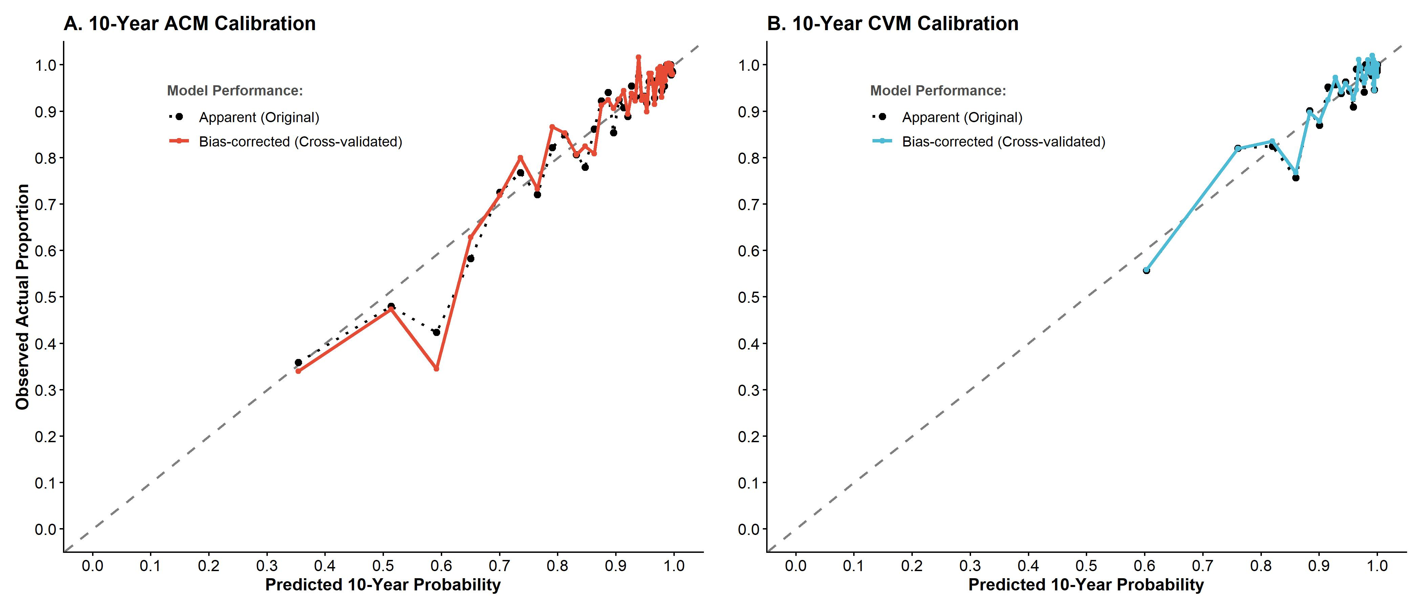
Figure 8: Figure 7: Calibration plots comparing predicted vs observed 10-years

15. Decision Curve Analysis (DCA)
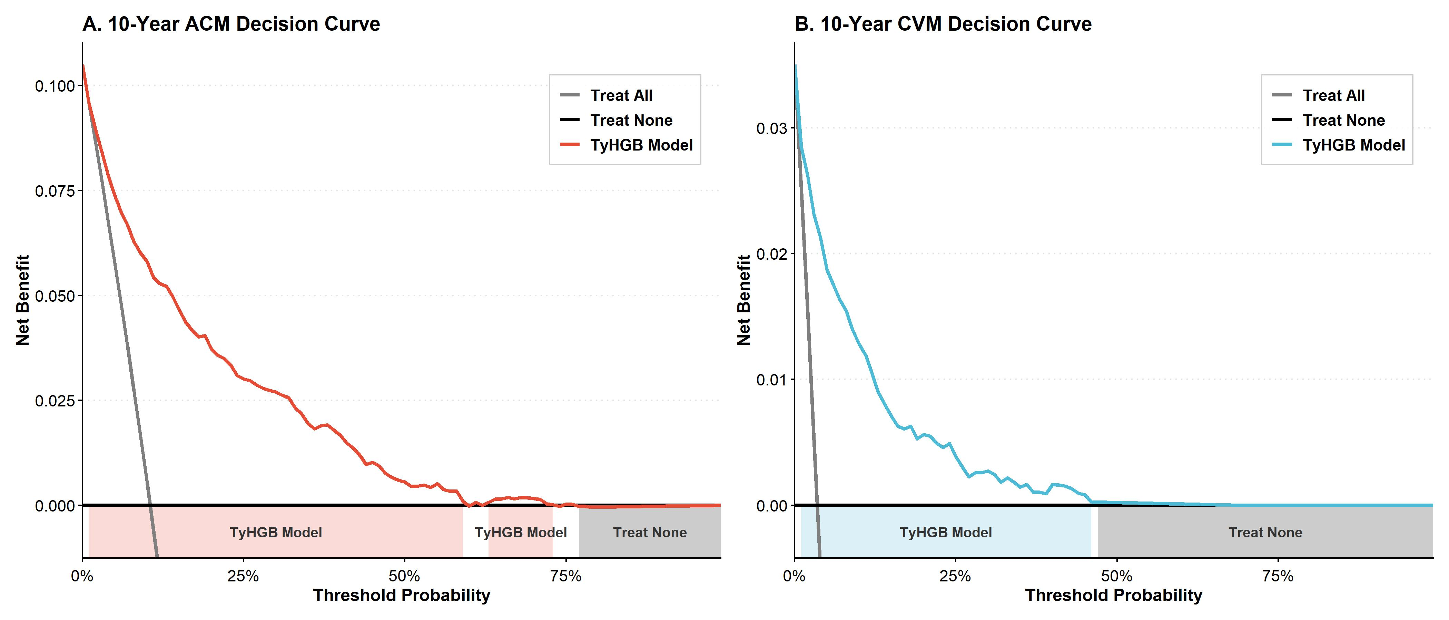
Figure 9: Figure 8: Decision Curve Analysis (DCA) demonstrating the net benefit of the TyHGB clinical model at 10 years

16. Multiple Imputation Stability Check (m = 20)
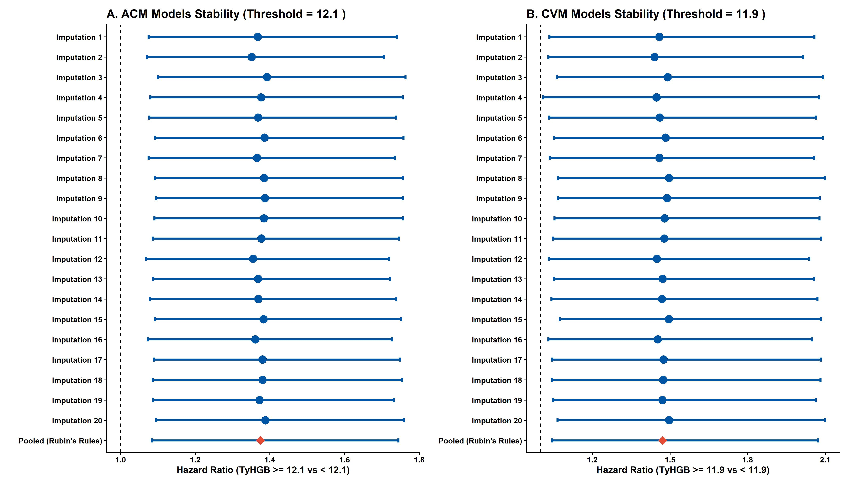
Figure 10: Supplemental Figure: Stability of the TyHGB prognostic value (High vs Low based on threshold) across 20 imputed datasets

17. E-Value Analysis
Stratified 1 - level Cluster Sampling design (with replacement)
With (184) clusters.
svydesign(id = ~SDMVPSU, strata = ~SDMVSTRA, weights = ~WTSAF2YR,
nest = TRUE, data = df_eva)
Stratified 1 - level Cluster Sampling design (with replacement)
With (184) clusters.
svydesign(id = ~SDMVPSU, strata = ~SDMVSTRA, weights = ~WTSAF2YR,
nest = TRUE, data = df_eva)
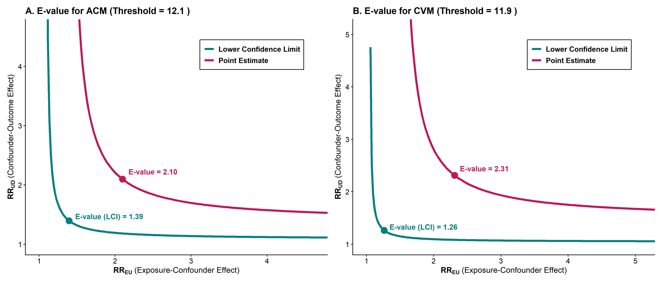
Figure 11: Supplemental Figure: E-value curves for the High vs Low TyHGB index on mortality

